DESIGN AND ANALYSIS OF ALGORITHM

FINDING THE TIME COMPLEXITY

PROBLEM 1:

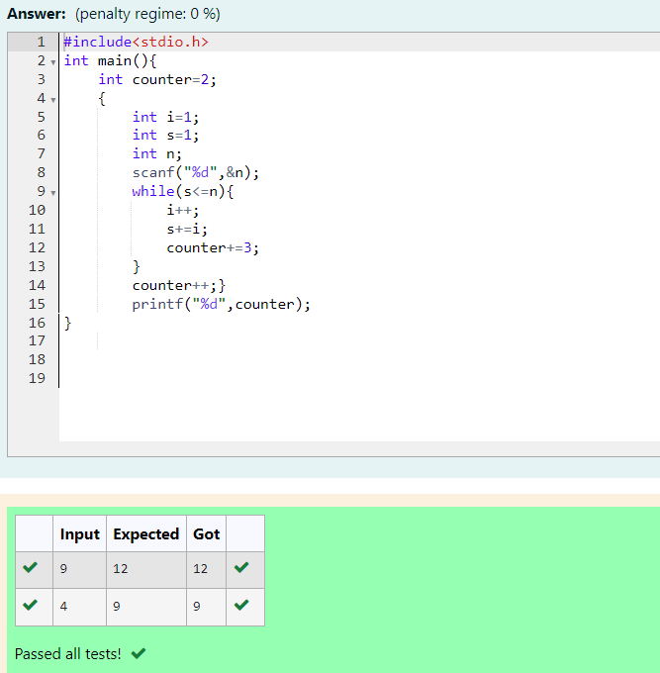

PROBLEM 2:

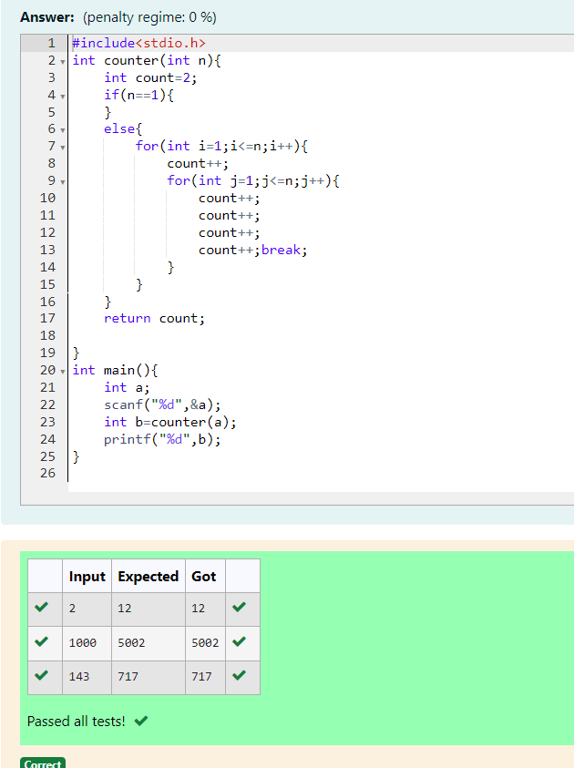

PROBLEM 3:

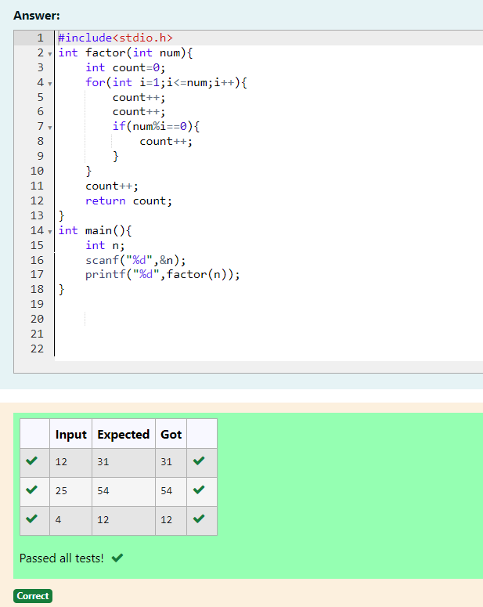

PROBLEM 4:

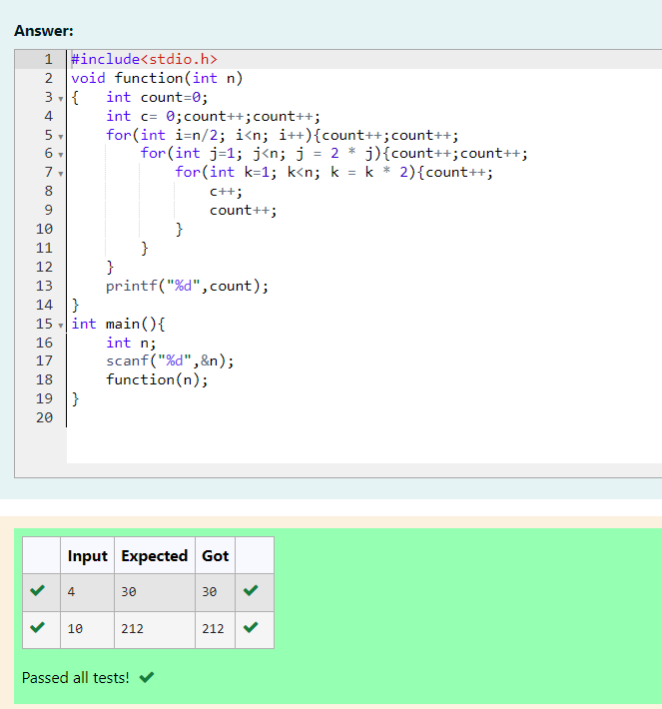

PROBLEM 5:

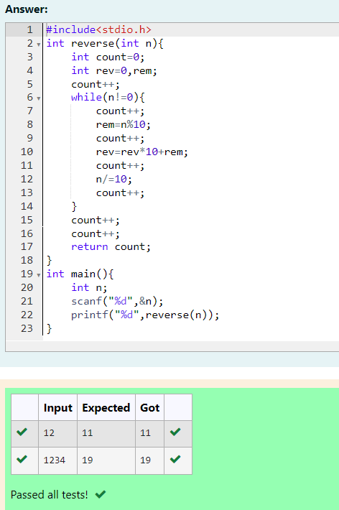

COMPETITIVE PROGRAMMING:

PROBLEM 1:

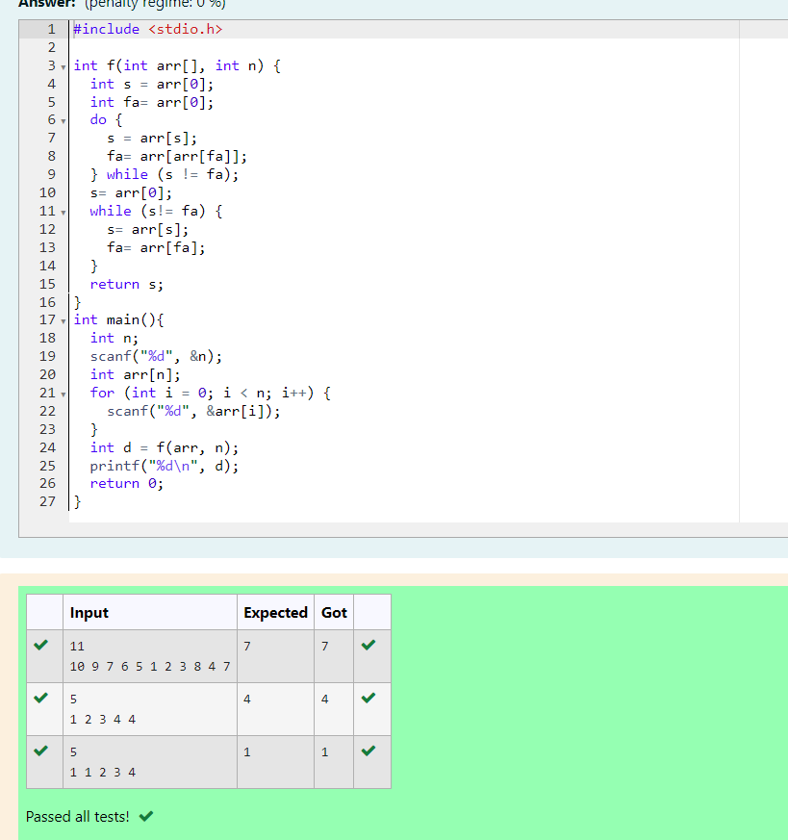

PROBLEM 2:

